PHP backend documentation

# General responses for wrong request:

## Not existing id:

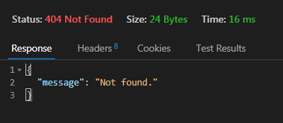

## Wrong Json format:

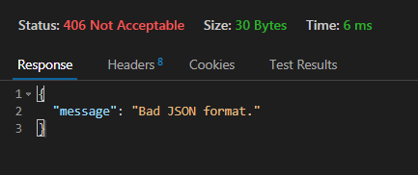

## Wrong method type:

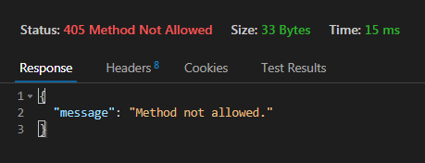

## Wrong JWT:

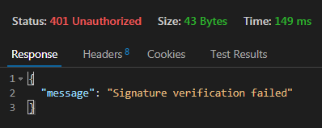

## Wrong JWT token period:

## 

# 

# User:

## Register:

Method: POST

URL: <http://localhost/PHP-backend-school/code/php/api/user/signUp.php>

JSON:

{

"firstName" : string,

"lastName" : string,

"email" : string,

"password" : string,

}

Correct request’s response:

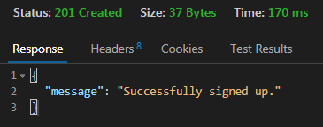

Special wrong request’s response (duplicated email-s):

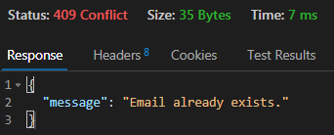

## Login:

Method: POST

URL: <http://localhost/PHP-backend-school/code/php/api/user/login.php>

JSON:

{

"email" : string,

"password" : string

}

Correct request’s response:

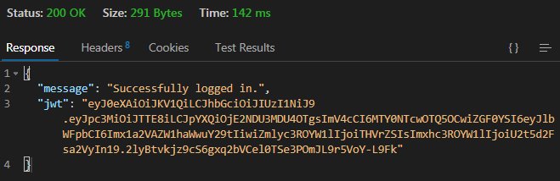

Contains the jwt token that will be needed to usid later in create, modify or delete requests

Special wrong request’s response (Wrong email or password):

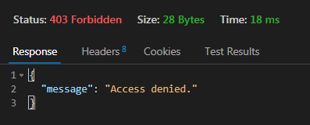

## Modify:

Method: PUT

URL: <http://localhost/PHP-backend-school/code/php/api/user/modify.php>

JSON:

{

"firstName" : string,

"lastName" : string,

"email" : string,

"password" : string,

“jwt” : string, (valid JWT token)

}

Correct request’s response:

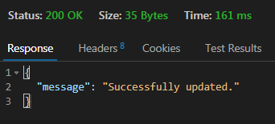

# Writer:

## GetAll:

Method: GET

URL: <http://localhost/PHP-backend-school/code/php/api/writer/getAll.php>

Correct request’s response:

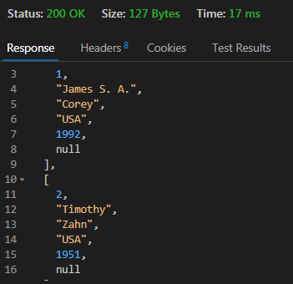

## GetById:

Method: GET

URL: <http://localhost/PHP-backend-school/code/php/api/writer/getById.php>

JSON:

{

"id" : number

}

Correct request’s response:

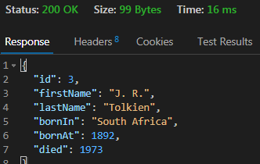

## Modify:

Method: PUT

URL: <http://localhost/PHP-backend-school/code/php/api/writer/modify.php>

JSON:

{

"id" : number,

"firstName" : string,

"lastName" : string,

"bornIn" : string,

"bornAt" : number,

"died" : number,

"jwt": string (valid JWT token)

}

Correct request’s response:

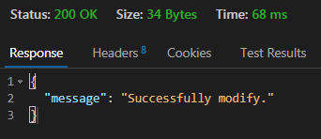

## Create:

Method: POST

URL: http://localhost/PHP-backend-school/code/php/api/writer/create.php

JSON:

{

"firstName" : string,

"lastName" : string,

"bornIn" : string,

"bornAt" : number,

"died" : number,

"jwt": string (valid JWT token)

}

Correct request’s response:

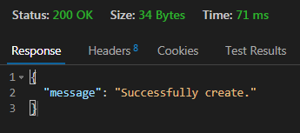

## Delete:

Method: DELETE

URL: <http://localhost/PHP-backend-school/code/php/api/writer/delete.php>

JSON:

{

“id” : number,

“jwt”: string (valid JWT token)

}

Correct request’s response:

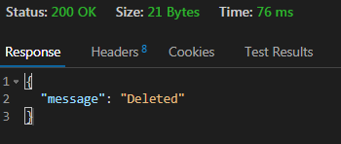

# Book:

## GetAll:

Method: GET

URL: <http://localhost/PHP-backend-school/code/php/api/book/getAll.php>

Correct request’s response:

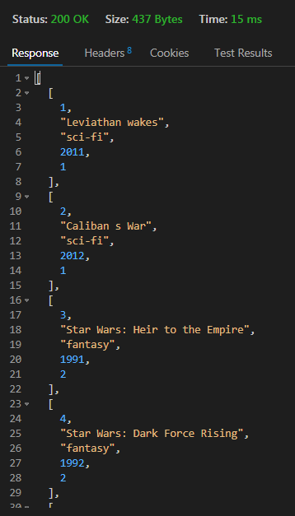

## GetById:

Method: GET

URL: <http://localhost/PHP-backend-school/code/php/api/book/getById.php>

JSON:

{

"id" : number

}

Correct request’s response:

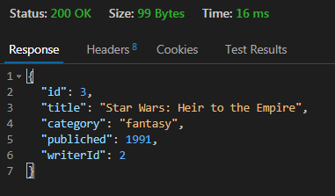

## GetByWriterId:

Method: GET

URL: [http://localhost/PHP-backend-school/code/php/api/book/getByWriterId.php](http://localhost/PHP-backend-school/code/php/api/book/getById.php)

JSON:

{

"id" : number

}

Correct request’s response:

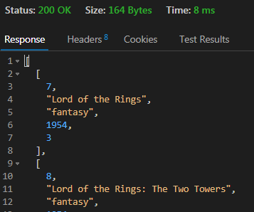

## Create:

Method: POST

URL: <http://localhost/PHP-backend-school/code/php/api/book/create.php>

JSON:

{

"title" : string,

"category" : string,

"published" : number,

"writerId" : number,

"jwt": string (valid JWT token)

}

Correct request’s response:

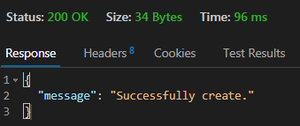

Special wrong request’s response (Not Existing writerId):

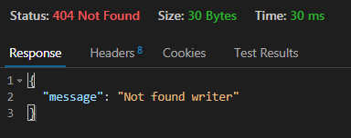

## Modify:

Method: PUT

URL: [http://localhost/PHP-backend-school/code/php/api/book/modify.php](http://localhost/PHP-backend-school/code/php/api/book/create.php)

JSON:

{

“id” : number,

"title" : string,

"category" : string,

"published" : number,

"writerId" : number,

"jwt": string (valid JWT token)

}

Correct request’s response:

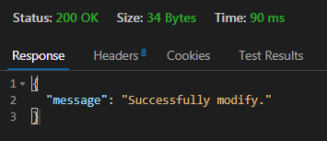

Special wrong request’s response (Not Existing writerId):



## Delete:

Method: DELETE

URL: <http://localhost/PHP-backend-school/code/php/api/book/delete.php>

JSON:

{

“id” : number,

“jwt”: string (valid JWT token)

}

Correct request’s response:

